PSSP

KS1 HOME LEARNING -

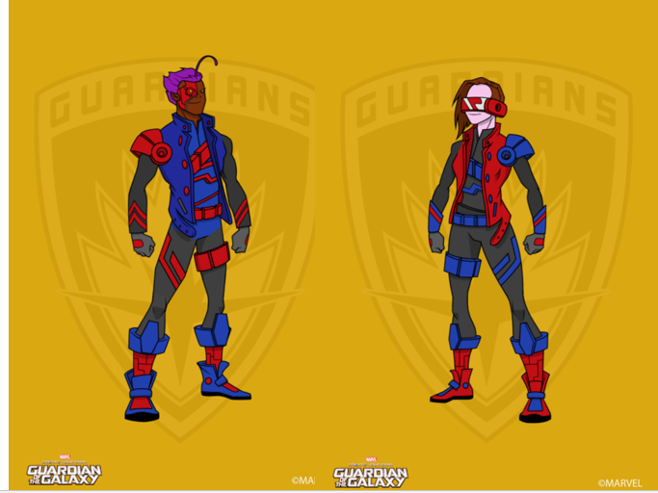
ACTIVE HEROES
Do you accept the
mission?

Attention: PSSP Active Heroes,

we need you!

Over the next few weeks, we need you to get your household active. We need the very best people on the job. Your mission, should you choose to accept, is to complete different activities every day to make sure we all stay fit and healthy? Only the best will survive – do you accept the challenge?
Let’s do this!
Captain Cormack, PSSP
Plymouthssp.co.uk

Each day, choose which activities you are going to do. The aim is for you to be active for at least 1 hour per day. The more challenges you complete, the higher the rating you will receive. Colour in each activity after you complete it and get your parent or guardian to sign the top of it. Want to change the activity for one of your own? Totally fine, just get active – write in the activity you did over the top of the ones in the box. You will need access to YouTube and some everyday items found around your house.

Complete 2 challenges in a day = Bronze
Complete 3 challenges in a day = Silver
Complete 4 challenges in a day =Gold
Complete 5 challenges in a day = Platinum
Send your completed weeks to your teachers so they can award your certificates and celebrate how active you have been. Feeling competitive? Why not challenge your friends or families to do the same activities as you?
Let’s get going Active Heroes – the challenge is on!
If you have permission, why not Tweet us @plymouthssp to let us know how well you are doing?

Standing Long Jump Challenge
Stand between 2 socks as a starting point. Jump as far as you can from 2 feet and land on 2 feet. Put another sock behind your heal and then measure (toe to heal) how far you jumped. What is the farthest you can jump?
Why not challenge other people in your house to beat your score? Or a classmate or friend?
Clap/Catch Challenge
Using a pair of socks, throw it in the air and clap before you catch them. Increase the claps by 1 each time. What is the highest number of claps you can do and still catch the socks?
Figure 8 Challenge
Pass a ball between both legs to make a figure 8. How many can you do in 1 min?
Too easy? Use a bigger ball
Too hard? Use a smaller ball

Around the World Challenge
Pass a ball around your waist as many times as you can without dropping it. How many can you do in 1 min?
Too easy? Use a bigger ball
Too hard? Use a smaller ball

Step Up Challenge
Use a small box, step or bench to step up onto and then back down again. Count how many times you can get both feet on top in 1 min.
Balance on 1 leg Challenge
How long can you balance on 1 leg? Which leg is easier? Time how long you can hold it.
Too easy? Can you do it with your eyes
Personal Challenges
Personal Challenges: These will help you improve your fitness, skills or performance. Try the challenge 3 times on Monday and 3 times on Friday – write down your best score each time. Are you getting better?

PERSONAL CHALLENGE SCORE SHEET
Figure 8 Challenge:
Monday’s score:

Friday’s score:
Standing Long Jump:
Monday’s score:

Friday’s score:
Clap/Catch Challenge:
Monday’s score:

Friday’s score:
Balance on 1 leg Challenge:
Monday’s score:

Friday’s score:
Step Up Challenge:
Monday’s score:

Friday’s score:
Around the World
Monday’s score:

Friday’s score:

Mon  WK 1 | Personal Challenge: Figure 8 challenge | 10 min Shake Up: Find Forky  (link on PSSP website) | YouTube: Cosmic Kids Yoga Club | Play outside for ½ hour | The daily mile
Tues  WK 1 | YouTube: Kids 9 min Cardio | YouTube: Ball Relay Funetics | YouTube: Cosmic Kids Yoga Club | Play outside for ½ hour | The daily mile
Wed  WK 1 | The Shape Game -Chorley Gymnastics club.co.uk | 10 min Shake Up: Anna’s Frozen Game (link on PSSP website) | YouTube: Cosmic Kids Yoga Club | Play outside for ½ hour | The daily mile
Thurs  WK 1 | YouTube: Trolls: Can’t Stop the Feeling. Go Noodle | YouTube: Bean Bag Balance Funetics | YouTube: Cosmic Kids Yoga Club | Play outside for ½ hour | The daily mile
Fri  WK 1 | Personal Challenge: Figure 8 challenge | 10 min Shake Up: Pumba’s Hippo Hops (Link on PSSP website) | YouTube: Cosmic Kids Yoga Club | Play outside for ½ hour | The daily mile
Mon  WK 2 | Personal Challenge:  Around the World Challenge | 10 min Shake Up: Yoga Yak (Link on PSSP website) | YouTube: Kids Yoga with Sheila Palmquist | Play outside for ½ hour | The daily mile
Tues  WK 2 | YouTube: Kids Workout Dance Minions | YouTube: Funetics Feed the Animals | 15 mins on your wheels – Bike/Scoot or Skate | Play outside for ½ hour | The daily mile
Wed  WK 2 | YouTube: Fun Gymnastics at Home Lesson 1 | 10 min Shake Up: Be Lumiere’s Guest (Link on PSSP website) | YouTube: Cosmic Kids Yoga Club | Play outside for ½ hour | The daily mile
Thurs  WK 2 | YouTube: Disney Dance Challenge 2 | YouTube: Funetics Jump the Stream | YouTube: Jungle Exercise for kids | Play outside for ½ hour | The daily mile
Fri  WK 2 | Personal Challenge: Around the World Challenge | 10 min Shake Up: Anna’s Frozen Game (link on PSSP website) | YouTube: Welcome to My Gym. Time 4 kids | Play outside for ½ hour | The daily mile

Mon  WK 3 | Personal Challenge:  Step Up Challenge | YouTube: Just Dance Kids Pirates | YouTube: Yoga for Kids with Animals | Play outside for ½ hour | The daily mile
Tues  WK 3 | YouTube: Just Dance Alladin | YouTube: Funetics I can Jump Higher | 15 mins on your wheels – Bike/Scoot or Skate | Play outside for ½ hour | The daily mile
Wed  WK 3 | YouTube: Exercise for Kids Indoor Workout | 10 min Shake Up: Pumba’s Hippo Hops (Link on PSSP website) | YouTube: Funetics Line Bounce | Play outside for ½ hour | The daily mile
Thurs  WK 3 | YouTube: Footloose Go Noodle | YouTube: Funetics Roll a Goal | YouTube: Yoga for Kids Strength | Play outside for ½ hour | The daily mile
Fri  WK 3 | Personal Challenge:  Step Up Challenge | YouTube: Kids 9 min Cardio | YouTube: Kids Yoga with Sheila Palmquist | Play outside for ½ hour | The daily mile
Mon  WK 4 | Personal Challenge:  Balance on 1 Leg | YouTube: Just Dance Kids I like to move it | YouTube: Cosmic Kids Yoga Club | Play outside for ½ hour | The daily mile
Tues  WK 4 | YouTube: Just Dance Disney Party Under the Sea | YouTube: Funetics Speed Bounce | 15 mins on your wheels – Bike/Scoot or Skate | Play outside for ½ hour | The daily mile
Wed  WK 4 | YouTube: Jurassic Chase Dinosaur PE | The Shape Game -Chorley Gymnastics club.co.uk | YouTube: Kids Home 10 Min workout | Play outside for ½ hour | The daily mile
Thurs  WK 4 | YouTube: Just Dance Kids 2 5 Monkeys | YouTube: Funetics Target Throw | YouTube:3 fun strength exercises for kids | Play outside for ½ hour | The daily mile
Fri  WK 4 | Personal Challenge:  Balance on 1 Leg | YouTube: Tabata Cardio Fun for Kids | YouTube: Sun Salutation/Yoga Animals | Play outside for ½ hour | The daily mile
Mon  WK 5 | Personal Challenge: Clap/Catch Challenge | YouTube: Musical Statues for Kids | YouTube: Cosmic Kids Yoga Club | Play outside for ½ hour | The daily mile
Tues  WK 5 | YouTube: Just Dance Let it Go | YouTube: Line Jump Workout for Kids | 15 mins on your wheels – Bike/Scoot or Skate | Play outside for ½ hour | The daily mile
Wed  WK 5 | YouTube: Tabata Workout for Kids | YouTube: Funetics Head, Shoulders, Knees & Toes | 15 mins on your wheels – Bike/Scoot or Skate | Play outside for ½ hour | The daily mile
Thurs  WK 5 | YouTube: Level Up 3! | YouTube: Funetics Rock, Paper, Scissors | YouTube: Yoga for Kids Strength | Play outside for ½ hour | The daily mile
Fri  WK 5 | Personal Challenge:  Clap/Catch Challenge | YouTube: Kids Games Balance Beam Games | YouTube: Cosmic Kids Yoga | Play outside for ½ hour | The daily mile
Mon  WK 6 | Personal Challenge:  Standing Long Jump Challenge | YouTube: The Floor is Lava: The Kiboomers | YouTube: Home Hand Eye Coordination Activities | Play outside for ½ hour | The daily mile
Tues  WK 6 | YouTube: Kids Workout Dance Minions | YouTube: Zookeeper Fitness | 15 mins on your wheels – Bike/Scoot or Skate | Play outside for ½ hour | The daily mile
Wed  WK 6 | YouTube: Jurassic Chase Dinosaur PE | 10 min Shake Up: Be Lumiere’s Guest (Link on PSSP website) | YouTube: Super fun kids workout | Play outside for ½ hour | The daily mile
Thurs  WK 6 | YouTube: Get Funky Do the Monkey | YouTube: Funetics Throw Golf | YouTube: Cosmic Kids Yoga | Play outside for ½ hour | The daily mile
Fri  WK 6 | Personal Challenge:  Standing Long Jump Challenge | YouTube: Fire & Ice Fitness challenge | YouTube: Yoga for Kids Strength | Play outside for ½ hour | The daily mile

