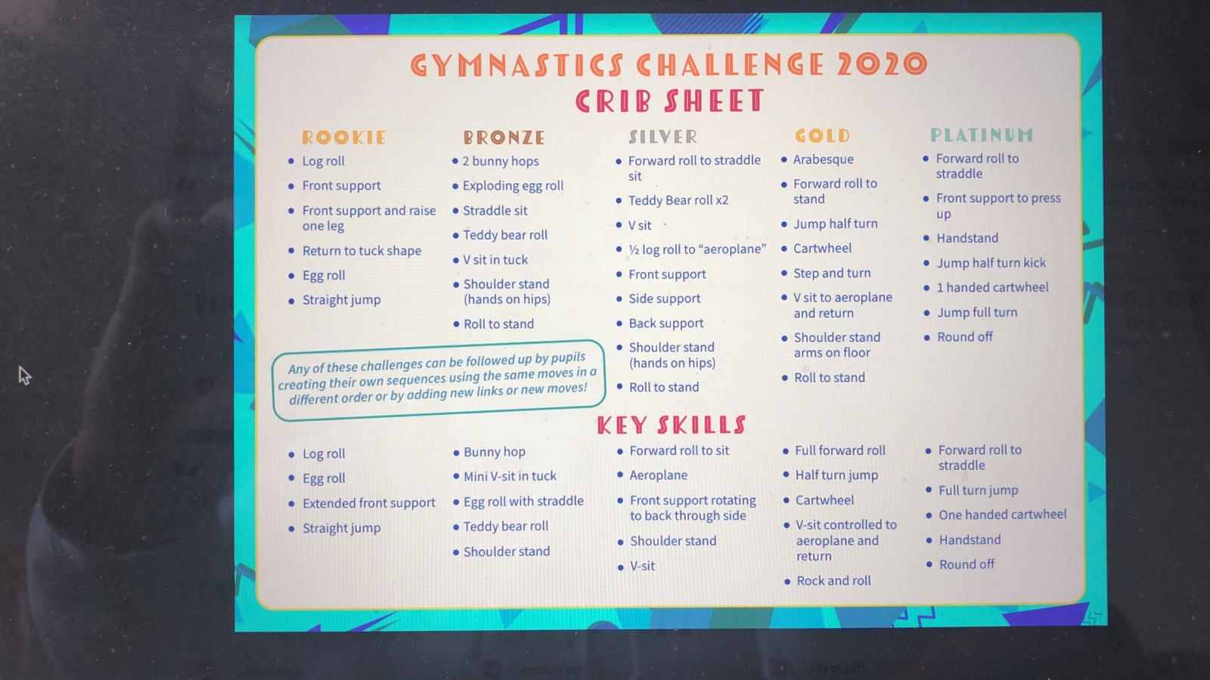

Rookie sequence - <https://youtu.be/WpTiB9sVrF8> (You tube - Ashton Park SSP Rookie challenge)

Bronze sequence – <https://www.youtube.com/watch?v=gFqDU5mQnsM> (youtube – Ashton Park SSP Bronze challenge)

Silver sequence – <https://www.youtube.com/watch?v=KV9bFiCAVQ8> (youtube – Ashton Park SSP Silver challenge)

Gold sequence – <https://www.youtube.com/watch?v=4It0s7_8QT0> (youtube – Ashton Park SSP Gold challenge)

Platinum sequence - <https://www.youtube.com/watch?v=bjcH0QDLlQA> (youtube – Ashton Park SSP Platinum challenge)