Keep up the Balloon
How to play:
Try to keep the balloon in the air using your pool noodle or paper plate bat.
How many times can you hit it before it falls on the floor?
Try with a friend or family member or event set out goals at either end of your area to get the balloon into.

What you need:
Balloons
Pool Noodle/ paper plate or bat

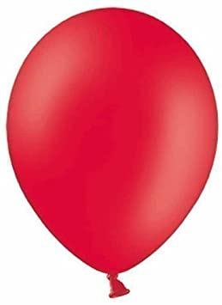
Too easy?
Add more balloons and try to keep them all in the air at the same time
Get the balloon from one end of the room to another
If you are using a paper plate, cut it into a smaller circle

