Target Games
Bean bag boccia – Start by throwing one bean bag for the target. Each child then takes a different colour bean bag and whoever throws theirs closest to the target is the winner!
Frisbee Golf (create obstacles for a child to shoot in with a frisbee such as bins/ plant pots (KANJAM)
https://www.youtube.com/watch?v=UBCh-KfYX4s
Jenga angry birds – Look at the Angry birds resources on the website – Stick them to jenga blocks and build towers then try to knock them down using balls
Balls on cones game – Set up a cone with a ball on top. See if you can knock it off by kicking, throwing or rolling a ball. Place the cone further away for each round.
King of the tower – One child stands in the middle protecting the tower (Ball on a cone). Other people must try to knock this tower down whilst the king try’s their best to protect it.
The mine game – Create a middle line in the garden or lounge with cones or a rope. Aim of this game is to have as few balls on your side as possible by throwing or kicking them to the other person’s half. After a certain time everyone freezes and the winner is the person with the least amount of balls in their half.
Cannon ball – Children (sailors) run across an area such as a garden whilst someone (pirates) roll small balls (cannons) at the sailors. If it hits them then they become pirates until the last sailor who’s the winner.
Monster ball - Children throw a tennis ball at a bigger ball such as a football or even bigger, every time someone throws a ball they must run back to their cone to throw another, person who hits the ball first wins.
Microwave – A bucket of balls are thrown in the air – the child that picks up all the balls the quickest is the winner! Alternatively, play this game with coloured paper shapes, the first to pick up all of their shapes wins!
Simon says
Head shoulders, knees, Cone! – Normal game but played with a partner with a cone in the middle, when CONE is shouted both children must try and grab the cone, child who gets the cone is the winner.
Treasure hunt – Create a list of items that children have to try and find around the house or garden or a certain room.
Hide and Seek
Balloon Keep ups – How many keep ups can your children do with their feet? Then try hands then try head then all parts of the body!
Sardines – One person hides whilst the others try to find them, once found they stay with them, the last person to find the hider has to hide first the next round!
Homemade Air Hockey! - https://www.facebook.com/ThePEShed/videos/2920353434857722/
Find The PE Shed on Facebook for some great ideas for home schooling
Human Hungry Hippos!
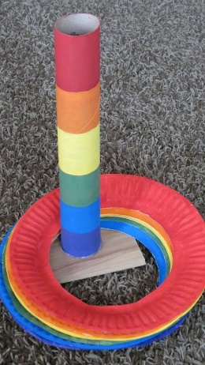
https://www.youtube.com/watch?v=W-xPyqPC_NY
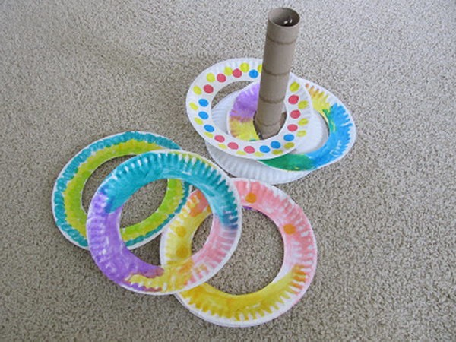
Hoopla

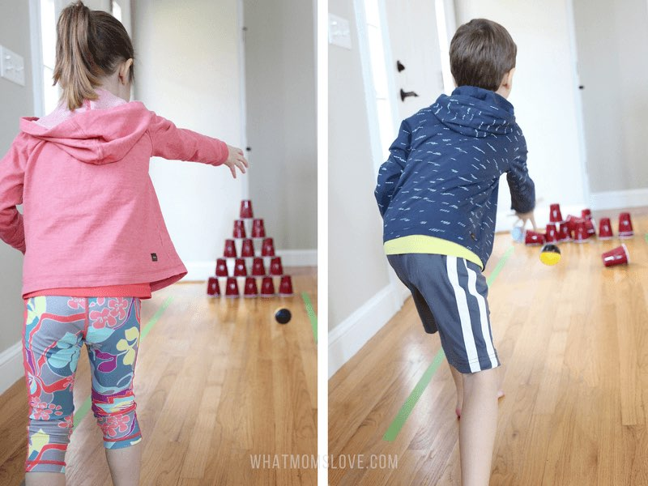
Cup Collapse

