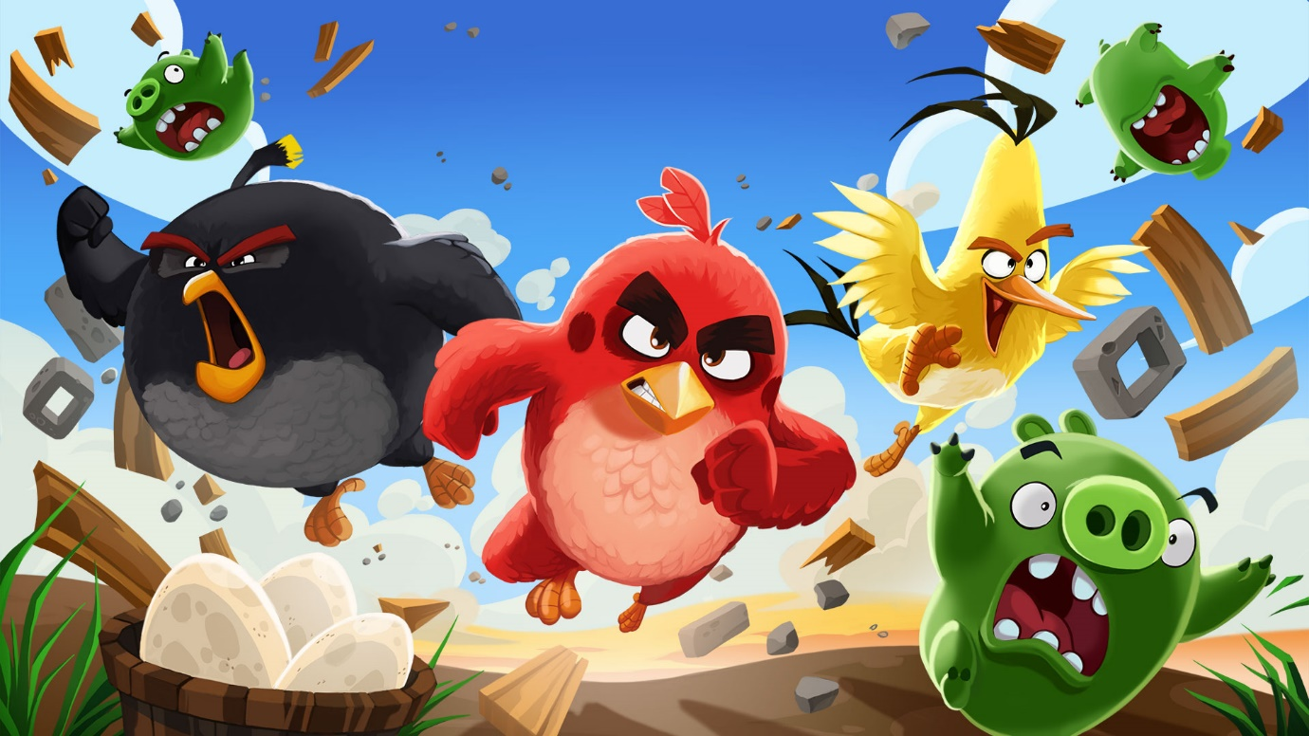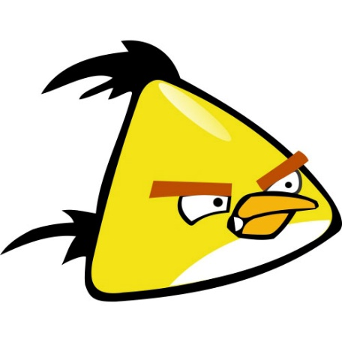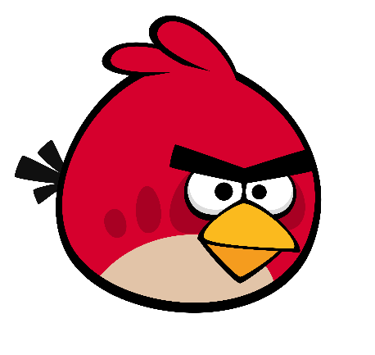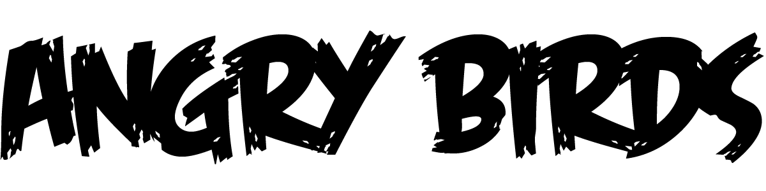

**Rules:**

1. Split the teams into two equal teams.
2. Each team needs to make a tower out of Jenga blocks and stick the angry birds onto the blocks.
3. Both teams get split into 2 groups and walk back about 3m.
4. Each person in the team has a tennis ball and takes on shot at the opposing team’s Jenga tower.
5. If all the balls are thrown and there is still tower left standing, all members of the team must collect their ball and try again.
6. First team to knock down the full tower, wins!

Equipment:

1. Angry birds activity pouch.
2. Giant Jenga blocks
3. Tennis balls

**JENGA**