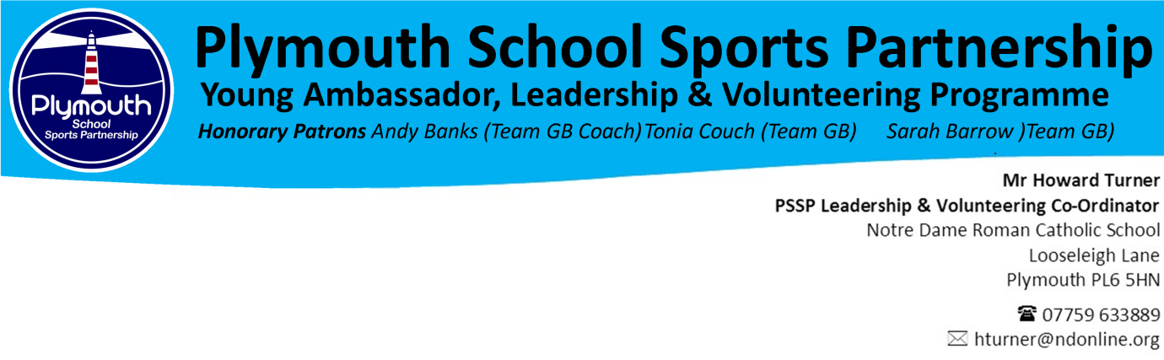Dear Parent/Guardian
I’m writing to confirm that you that your son/daughter has been booked a place on the RFU Level 1 Key Stage 4 Leaders Award which will take place on:
DATE: Wednesday 22nd April 2020
VENUE: King George V Playing Fields, Elburton, PL98HR
TIME: 10.00 to 15.00

This award is being funded by the PSSP and is offered to students FREE of charge in return for them committing to help officiate at the PSSP Level 2 School Games Year 3/4 Primary Rugby Festival on Thursday 7th May 2020.
Students do not need to be accompanied by a member of staff & will need to make their own way to and from the venue and will attend the day at their own risk.
Please be aware:
- By signing up for the FREE award they are committing to help officiate at the PSSP Level 2 Primary Tag Rugby Festival at Plymouth Albion on Thursday7th May 2020
- All practical activity will be taking place on grass, so football boots are required
- Students will need to bring a completed consent form with them on the day
- On arrival students will need to report to the main changing facility at KGV
- Arrive 9.30 to 10.00 for registration
- Bring lunch, snacks and drinks for the duration of the award
- Bring some warm sports clothing, waterproof jacket and a change of clothes

The award is being coordinated by the Plymouth School Sports Partnership and will be delivered by fully qualified staff/tutors. Whilst at the facility students will be covered by the venues risk assessments, health and safety policies and public liability insurance. The emergency contact for the day is Mr H Turner; 07759 633889

The RFU Official Award is of a practical nature, so students will need to arrive at the venue clothed and equipped for physical activity.
Please find attached an attendee consent form which must be completed and returned on the day.
Please be aware that by completing and returning the consent form you are also supplying consent to share your son/daughters contact details with the Plymouth School Sports Partnership. All data will be kept in accordance with General Data Protection Regulations. For further information on how we store your data, please visit www.plymouthssp.co.uk
If you have any concerns or questions regarding any of the above information, please contact Mr Turner on: 07759 633889 or alternatively email: hturner@ndonline.org
Yours faithfully
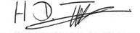
Mr HD Turner (PSSP Leadership & Volunteering Coordinator)

PLYMOUTH SCHOOL SPORTS PARTNERSHIP
Parental Consent Form: RFU Level 1 Key Stage 4 Leadership Award

Dear Parent / Carer,
Please complete and return this form which relates to this forthcoming activity. This form gives your consent for your child to take part in the activity.

VISIT OR ACTIVITY: RFU Level 1 Key Stage 4 Leadership Award

DATES AND TIMES: Wednesday 1st May 2019

NAME OF STUDENT: DATE OF BIRTH:
STUDENT EMAIL: STUDENT MOBILE:

SPECIAL DETAILS
Any relevant information concerning your child’s health requiring special attention but which does not prevent her / him from taking part should be noted below. For example, does your child:
- have any allergies?

- take medication and if so what is it and what is the dosage required?

- experience any travel sickness?

- have diabetes, asthma or epilepsy?

Has your child had any relevant recent illness?

Does your child have any special dietary requirements?

FAMILY DOCTOR

PRACTICE / CLINIC TELEPHONE

Approximate date of last tetanus injection

- I would like my child to take part in the above mentioned visit or activity and, having read the information provided, agree to her / him taking part in the activities described.
- I AGREE TO MY SON/DAUGHTER NAME, GENDER AND CONTACT INFORMTION BEING SHARED WITH RELEVANT PARTIES

- I consent to any emergency medical treatment required by my child during the course of this visit.

- I confirm that my child is in good health and I consider her / him fit to participate.

- I understand that good behaviour is expected for the enjoyment and safety of all participants and persistent poor conduct will result in me having to collect my child from the activity, or a member of staff transporting them back to school. In this instance no refunds will be paid.

- I understand that if any details on this form change before the activity, a new form must be completed and returned.

Signature of
Parent/Carer Date

NAME OF PARENT/CARER

ADDRESS OF PARENT/CARER

CONTACT DETAILS OF PARENT/CARER

HOME NUMBER

WORK NUMBER

MOBILE NUMBER

DETAILS OF STUDENT (IF DIFFERENT TO THE ABOVE)

STUDENT HOME ADDRESS

STUDENT HOME NUMBER

Plymouth School Sports Partnership
Activity Risk Assessment: RFU Level 1 Key Stage 4 Rugby Leaders Award

Venue: King George V Playing Fields Activity Leader: Howard Turner Emergency Contact: 07759 633889 Date: 22/04/20

Aspects to Consider | Person Affected | Risk Rating | CONTROL MEASURE: Action required to reduce risk to an acceptable level
Risk | Staff (S)  Pupils (P)  Visitors (V) | Low (L)  Medium (M)  High (H) | Controls and Further Action | Action by | Completed
Transportation | S/P | N/A | - Students, tutor & staff will be making there own way to & from the facility | N/A | N/A
Fire & Emergency | S/P | Low | - The Tutor will have a clear understanding of evacuation & emergency procedure  - The tutor will inform students of emergency evacuation procedures before the commencement of activity  - The tutor will meet their group in designated emergency meeting point & check all registered students are in attendance | HDT  Tutors
Injury caused by wearing inappropriate clothing or footwear | S/P | Low | - It will be the responsibility of the award tutor to check that all participants are wearing safe & appropriate clothing & footwear  - It is the responsibility of award tutors to check for jewellery  - Any jewellery being worn to be removed by the participant | Tutors
Injury caused by inappropriate behaviour during activity | S/P | Low | - It is the responsibility of the tutor to set out expectations of behaviour in their sessions  - Students will be removed from activity if their behaviour is causing a risk to themselves & others  - A member of staff will be available to remove students from sessions on request of the tutor  - An emergency number will be issued to all tutors | Tutors  HDT
Injuries or issues caused as a direct result of tutor actions | P | Low | - The tutor holds a minimum of Netball England Level 2 coaching qualification and are experienced at delivering the Netball Young Organiser Award  - Tutor qualifications & DBS certification will be held by the appropriate NGB Coaches/Tutors will be covered by their own or their NGB public liability insurance  - The sessions will be visited by organiser to make sure the delivery is of a sufficient safe & appropriate quality | Tutors
Injury caused by facilities or venue | P | Low | - It is the tutor responsibility to perform a visual inspection of the working area & any equipment being used before the commencement of the activity  - At the facility, all students, staff & instructors will be covered by the facilities health & safety policies, risk assessment & public liability insurance  - Health & safety issues regarding the environment will be reported to the facility management  - Equipment that is found to be of risk will be removed from use | Tutors
Injury caused by lack of first aid cover | P | Low | - First aid bags will be available from the site & activity coordinator  - A designated first aider will be on site & available throughout the duration of the day | Tutors  HDT
Injury caused by lack of break & lunch time supervision | P | Low | - Areas will be designated for break & lunch time  - Students will be advised not to leave the site during break & lunch time | HDT
Issues caused by use of toilets | S/P | Low | - The site will be closed to members of the general public  - There will be designated separate staff/coach/tutor & student toilets | N/A

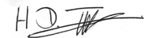
Signed: Date: 30/11/19

