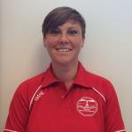 | My name is Claire Cormack. I work for the Plymouth School Sports Partnership.
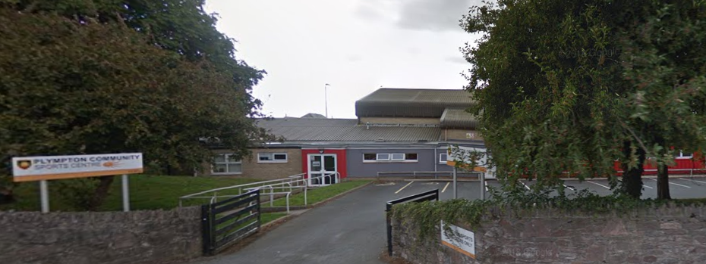 | I run the Boccia event at Plympton Academy.
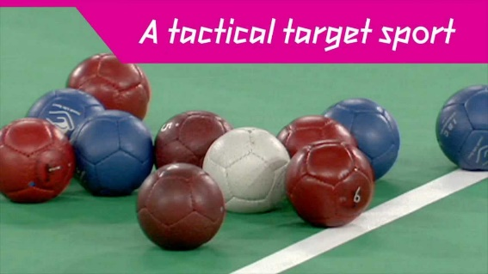 | Boccia is a sport that is played sat down. The aim is to get your colour balls closer to the white ball than the other team by rolling them.
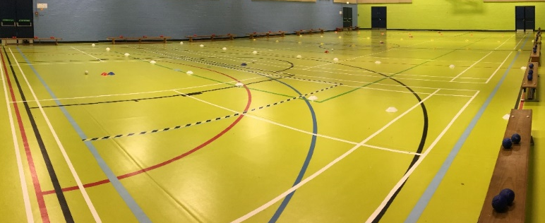 | We play in the sports hall and there will be some older students who will help us and referee our games.
 | We hope that it will be a fun event where you can play with your team and meet children from other schools.
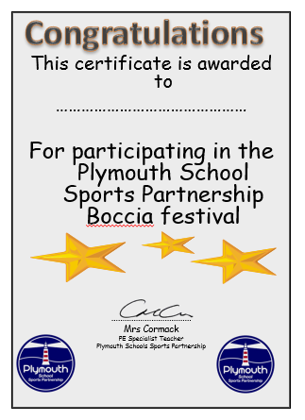 | At the end of the event, everyone who took part will receive a certificate.

