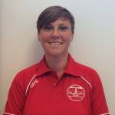 | My name is Claire Cormack. I work for the Plymouth School Sports Partnership.
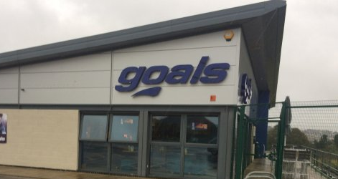 | I run the Football event at Goals. Lots of different schools send along their teams to take part in our friendly competition.
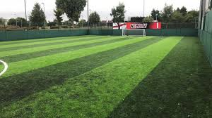 | We play on an artificial pitch so that it does not get too muddy when it rains.
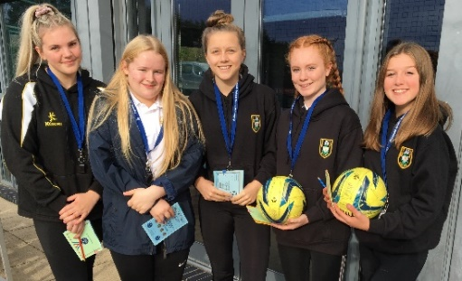 | We often have some older students with us to referee the games.
 | We hope that it will be a fun event where you can play Football with your team and meet children from other schools.
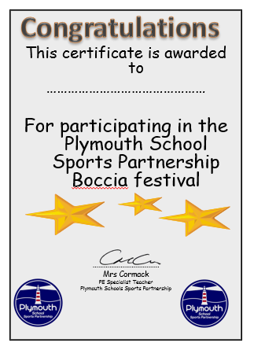 | At the end of the event, everyone who took part will receive a certificate.

