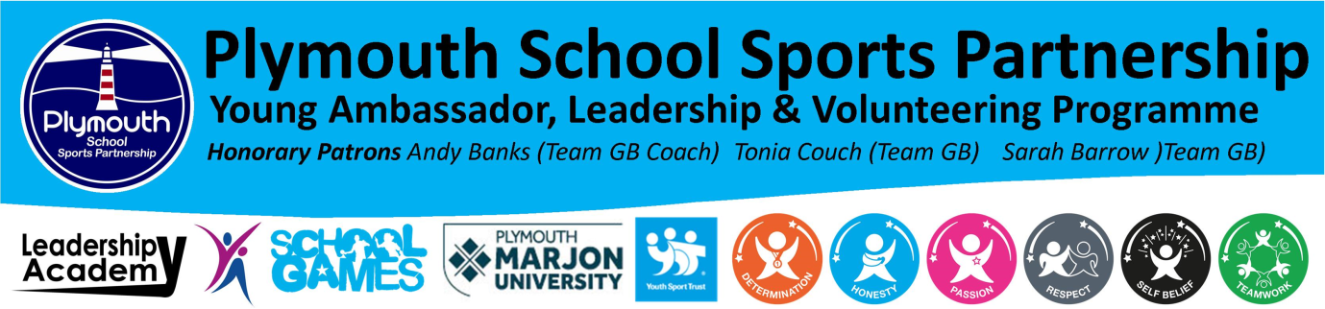

England Athletics Assistant Officials Award

DATE: Thursday 25th April 2019
VENUE: Derriford Centre for Heath & Wellbeing, Derriford Road, Plymouth, PL6 8DH
TIME: 10.00 to 15.00
PLACES: 30 (Places will be allocated on a first come first serve basis)

England Athletics Assistant Officials Award:
The award is open to all leaders who are 14+ .

The Award: Who should go on this course?
Anyone aged 14 or over interested in gaining an insight and introduction to the key areas of officiating that will enable them to assist at track and field meetings under the supervision of a qualified UKA Technical Official.

What will I learn?
Delivered as a single workshop of four hours in six sections with both theoretical and practical elements covering:
- The responsibilities and role of an Assistant Official
- Measuring and recording times and distance
- Making, sharing and recording judgements
- Ensuring safety and reporting concerns
- Communicating with athletes and other officials
- Following procedures and applying basic rules

Next steps - After completing the course candidates will need to:
- Gain experience by attending a minimum of two athletics meetings assisting a qualified Official.
- Complete a Recorded Evidence Form detailing each meeting and have this signed by a qualified UKA Technical Official. (These experiences can also be gained at schools’ athletics meetings, signed off by the appropriate teacher.)
- Undertake a DBS check, if aged 16 or over, or if under 16 make a Self-Declaration.
- A Level 1 Assistant Officials’ Licence will then be issued.

Booking places on the award:
Booking for the award is open and can be made via the PSSP events page. The award cost will be covered by the PSSP so the award will be offered FREE to all attendees. In return for the free award all attendees are expected to help officiate one or more of the following school athletics events

Thursday 2nd May: School Games Year 5/6 Level 2 Quadkids
Tuesday 7th May: School Games Level 2 Year 3/4 Quadkids
Tuesday 7th May: School Games Level 2 Super 8 Start
Tuesday 11th June: PSSP Brickfields Primary Athletics

Please could you make your students aware:
- By signing up for the FREE award they are committing to help officiate at one or more of the above Plymouth athletics events
- All practical activity will be taking place in a sports hall, so please wear appropriate clothing and footwear
- Students will need to bring a completed consent form with them on the day
- Students will need to report to the sport hall at the Derriford Centre for Heath & Wellbeing on arrival
- The award will start at 10.00, so participants will need to arrive from 09.30 onwards
- Please Bring lunch, snacks and drinks for the duration of the award
- The emergency contact for the afternoon will be: Howard Turner: 07759 633889 or hturner@ndonline.org

Best wishes
Howard

